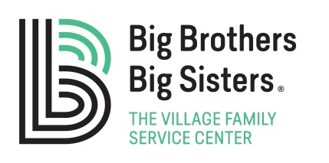

School-Based Volunteer Match Groundrules

I agree:

- To see my Little Brother/Little Sister on a consistent basis for at least one school year.
- To not include other people on our visits.
- To keep personal information about my Little Brother/Little Sister and the family members confidential.
- That all match activities will take place on school grounds.
- To sign in at the school office prior to all mentoring visits.
- That the only form of acceptable discipline in my relationship with a Little Brother/Little Sister is to verbally identify the behavior that is causing the problem and what needs to change so the activity can resume. If necessary, I will contact the student’s teacher or other school personnel if there is a behavior problem.
- That if I am involved in an incident of questionable behavior (ex: alcohol misuse, chemical dependency, criminal charges, etc.) The Village will suspend the match until an investigation of the matter is concluded. The Case Manager, Program Director and Vice President will be involved in deciding as to the continuation of the match. I understand the decision will be made in the best interest of the Little Brother or Little Sister.
- To respond promptly to phone calls and letters from BBBS staff.
- To contact my Case Manager with any questions or concerns.
- That my Little Brother/Little Sister needs to be in my care at all times during our mentoring visits (this includes walking him/her back to the classroom, MASH, etc.).
- To notify the program promptly when any changes occur in my employment, residence, telephone number or email address.
- To report immediately any knowledge or suspicion of abuse or neglect of my Little Brother/Little Sister to my Case Manager.
- To actively participate in the closure procedures for my match.

I understand that failure to comply with the above agreement may result in closure of my match.
I hereby agree to meet the requirements and to fulfill the duties stated above to the best of my ability. I further state that I have disclosed all information about my past history or personal character which may adversely affect my acceptance or performance as a Big Brother or Big Sister or could be detrimental to the child’s or program’s best interests. I understand that The Big Brothers Big Sisters Program is not obligated to match a child with me. If accepted I further understand that all matches are subject to parental approval.

Signature __________________________________________ Date ______________________

